Fundraising Dinner
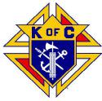 | Westchester Putnam Chapter  Knights of Columbus  will host a | 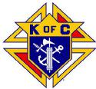

To benefit
St. Joseph’s Seminary
and Our Seminarians
Monday~ November 4th, 2019
6:30 PM Dinner
Fr. Dunphy Council
139 N. Broadway
White Plains, NY
$40 Per Person
Space is LIMITED—RESERVATIONS DUE OCT 11, 2019!
For more information contact:
Steven Brundage: 914-310 -9150 slblawyerz@optonline.net or
Dan Daudier: 914-393-7035 ddaudier@aol.com

RETURN THIS SECTION WITH YOUR PAYMENT... RETURN THIS SECTION WITH YOUR PAYMENT... RETURN THIS SECTION WITH YOUR PAYMENT...

Please make checks payable and send to:

I would like to support our seminarians!
Name
Phone
Number of Guests X $40 =_____
Total =_____
Westchester Putnam Chapter PO BOX 144
Montrose, NY 10548
SUPPORT
OUR
SEMINARIANS

