COMBINATION
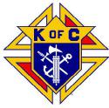 | Westchester Putnam Chapter  Knights of Columbus  will host a | 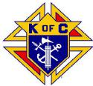

ANNUAL AWARDS GALA
AND
SEMINARIAN DINNER
SUNDAY, November 14, 2021
12:00 PM to 5:00 PM
Mulino’s Lake Isle
660 White Plains Rd
Eastchester, NY 10709
DETAILS TO FOLLOW

SAVE THE DATE!!

