Westchester Putnam Chapter
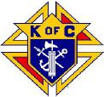
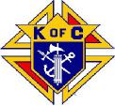
Knights of Columbus
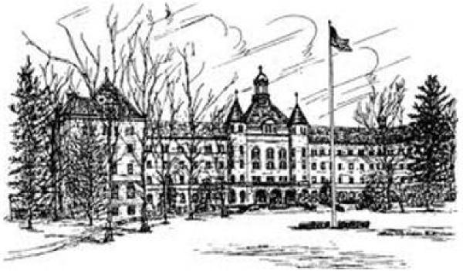
Fundraising Dinner
to benefit St. Joseph’s Seminary
Journal Form
We encourage you to copy this form and ask local businesses and organizations
to support our seminarians. Your assistance will be greatly appreciated.
Full page $250 (approx 5.5 x 8.5'')
Half page $175 (approx 5.5 x 4.25")
Please complete and return this form to the address below by October 11, 2019
Name of Donor:
Amount Paid: Contact Person:
Phone: Email Address:
Please make check payable to: Saint Joseph Seminary and send to:
Westchester Putnam Chapter - PO. Box 144, Montrose NY 10548
Steven Brundage 914-310-9150 (Cell) email: slblawyerz@optonline.net
Please email the JOURNAL AD
No phone calls after 9:00 PM

