Seminarian Dinner
Raffle
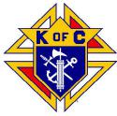 | Westchester Putnam Chapter  Knights of Columbus | 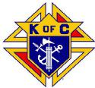

Help Support
St. Joseph’s Seminary
and Our Seminarians
Drawing: Monday~ November 4th, 2019
Grand Prize:* 6 Nights Accommodations at 3 bedroom house in Poconos Mountains-Allbrightsville, PA
OR 6 Nights Accommodations at 3 bedroom condo in Legends Golf Resort, Myrtle Beach, SC
Second Prize: 50 inch 4K Ultra HD LED Television
Third Prize: Specially Selected Golf Items
Fourth Prize: 2 chances to win! $50 gift cards

*requires 60 day advance notice of selected dates, some date restrictions apply
Price: $5 per Ticket
Questions? Contact Steven Brundage: slblaywerz@optonline.net (914) 310-9150 or
Dan Daudier: ddaudier@aol.com (914) 393-7035
Please make checks payable and send along with completed stubs
BY OCTOBER 11, 2019 to:
Westchester Putnam Chapter
PO BOX 144
Montrose, NY 10548
SUPPORT
OUR
SEMINARIANS

